# More Exercises: Advanced Arrays

Problems for exercise and homework for the ["JS Fundamentals" Course @ SoftUni.](https://softuni.bg/trainings/3449/programming-fundamentals-with-javascript-september-2021)   
Submit your solutions in the SoftUni judge system at: <https://judge.softuni.org/Contests/1301>

## Equal Neighbors

Write a function that finds the number of equal neighbor pairs inside a matrix of variable size and type (numbers or strings).

The **input** comes as **array of arrays**, containing string elements (2D matrix of strings).

The **output** is return **value** of you function. Save the number of equal pairs you find and return it.

**Examples**

|  |  |  |  |  |
| --- | --- | --- | --- | --- |
| **Input** | **Output** |  | **Input** | **Output** |
| [['2', '3', '4', '7', '0'],  ['4', '0', '5', '3', '4'],  ['2', '3', '5', '4', '2'],  ['9', '8', '7', '5', '4']] | 1 | [['test', 'yes', 'yo', 'ho'],  ['well', 'done', 'yo', '6'],  ['not', 'done', 'yet', '5']] | 2 |

## Bunny Kill

*In the underground world of bunnies, mafia and corruption have taken over. Snowball is on a mission to infiltrate a certain deserted military hanger, supposedly filled with convict bunnies.*

You will be given a **matrix** of integers, each integer separated by a **single space**, and each row on a new line, which will represent the current situation in the hangar. Then on the last line of input you will receive indexes - **coordinates** to several cells in the hangar separated by a **single space**, in the following format: **row1,column1 row2,column2 row3,column3…**   
On those cells there are bunnies with **bombs**. Snowball is smart and knows that the bombs are an easy way to neutralize enemies, especially when they are the enemy’s own bombs.

Snowball will proceed to eliminate **every** **bunny with a bomb**, one by one in the order they were given. When a bunny with a bomb is killed, it **explodes** and deals damage **equal** to its **own** **integer** **value**, to **all** the cells **around** it (in every direction and in all diagonals). If a bomb bunny is caught in the explosion and killed, that bomb is no longer valid and will **not explode**. When a bunny is damaged, it **reduces** its integer value by the **damage** value. When a bunny’s value reaches **0**, **it dies**. When a bunny explodes, **it dies**.

When Snowball is done with all the bomb bunnies, he will proceed to kill any other convict bunny which has remained **alive**. You must count all the **damage** Snowball did in the hangar. Note that bomb explosion damage **does not** count as Snowballs damage, but the killing of bomb bunnies and other bunnies **DOES.** Snowball’s damage for every bunny is equal to the bunny at that cell’s **integer value**.

### Input

* The input data is passed to the first function found in your code as an **array of strings**.
* Each entry in the array represents a row of the matrix, in the form of integers separated by a space.
* On the last line you will receive the coordinates of the cells with the bomb bunnies.

### Output

* On the first line you need to print Snowball’s **damage**.
* On the second line you need to print the amount of bunnies **HE** killed.

### Constraints

* The size of the matrix will be between **[0…1000].**
* The coordinates to the bomb bunnies will **always** be in the matrix.
* The integers of the matrix will be in range **[0…10000].**
* Allowed time/memory: 250ms/16MB

### Examples

|  |  |  |
| --- | --- | --- |
| **Input** | **Output** | **Comments** |
| ['10 10 10',  '10 10 10',  '10 10 10',  '0,0'] | 60  6 | The blue number represents a bunny which is a bomb. The red numbers are bunnies which have been hit by the exploding bunny. Since the exploding bunny has a value of 10, all the damaged bunnies suffer 10 damage. Since their values are also 10, the explosion kills them and they are no longer valid targets for Snowball. So in total Snowball deals 60 dmg (the 5 untargeted bunnies + the exploding one) and kills 6 units. |

|  |  |  |
| --- | --- | --- |
| **Input** | **Output** | **Comments** |
| ['5 10 15 20',  '10 10 10 10',  '10 15 10 10',  '10 10 10 10',  '2,2 0,1'] | 70  7 | Here the purple bunnies are caught in the explosion, but since their values are bigger than the exploding bunny’s value – they don’t die and are left for Snowball to kill.  The damage Snowball deals here is 10 + 10 + 5 + 20 + 10 + 5 + 10 = 70. The values for the bunnies who survived the explosion are 5 because the explosion reduced their initial values  15 (initial) – 10 (exploding bunny) = 5 |

## Air Pollution

Write a program that tracks the **pollution** **in the air** above Sofia. You will receive **two arguments** – the **first** is the **map** of Sofia represented by a **matrix of numbers** and the second is an **array of strings** representing the **forces** **affecting** the **air quality**. The **map** will **always** be with **5 rows** and **5 columns** in **total** **of** **25 elements - blocks**. Each block’s particle pollution (PM) is **affected** by **3 forces** receivedin the following formats**:**

* **"breeze {index}" –** index is **the row** where **all column’s value drops** by **15** PM
* **"gale {index}" –** index is **the column in all rows** where **value drops** by **20** PM
* **"smog {value}" – all** **blocks** in the map **increase** equally by **the given value’s** PM

The threshold in each block is **50** PM. If it is **below** **that number**, the block’s air is considered **normal** but if it **reaches or goes over it,** that block’s air is considered **polluted**. Also note that the **polluted particles** in a block **cannot go below** **zero**.

Finally, your program needs to **find** if there are **any polluted blocks** and **print them** in the format given below.

**Input**

You will receive **two** **arguments**:

* The **first** argument is an **array with five strings** – **rows** of the matrix with **columns separated by space** that must be parsed as **numbers**, representing the **map of Sofia**.
* The **second** argument is an **array of strings** – each **string** consists of one of the **words (breeze/gale/smog)** and a **number** **separated by space**, representing the **different forces**.

**Output**

Print on the **console** a **single line**:

* If there are **polluted blocks** in the map, **use** their **coordinates** in the following format:
* **"[{rowIndex}-{columnIndex}]"**

Note that you must **start** from the **top left corner** of the map moving to the **bottom right corner** **horizontally**. Then **separate** each **formatted block’s coordinates** with **comma and space** and print them in a single line in the following format:

* **"Polluted areas: {block1}, {block2}, {block3}, …"**
* If there are **no polluted blocks** in the map print:
* **"No polluted areas"**

**Constraints**

* The **number** of **rows** and **columns** for the **matrix** will **always** be **5**
* The **number** in each block will be an **integer** in range **[0..1000] inclusive**
* The **number** of **elements** in the **second input argument** will be in range **[0..100] inclusive**
* Given **smog’s** **value** will be an **integer** in range **[0..100] inclusive**
* Given **indexes** will **always** be **valid**

**Examples**

|  |  |
| --- | --- |
| **Input** | **Output** |
| ['5 7 72 14 4',  '41 35 37 27 33',  '23 16 27 42 12',  '2 20 28 39 14',  '16 34 31 10 24'],  ['breeze 1', 'gale 2', 'smog 25'] | Polluted areas: [0-2], [1-0], [2-3], [3-3], [4-1] |

**Explanation**

Graphic diagram explaining the **first example’s** program flow:

**input**

**breeze 1 (-15)**

**gale 2 (-20)**

**smog 25 (+25)**

**polluted areas**

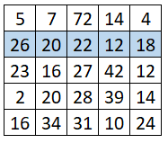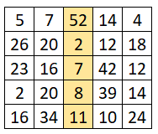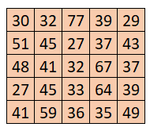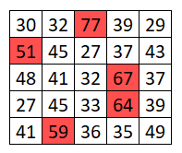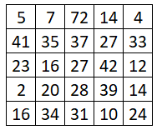

|  |  |
| --- | --- |
| **Input** | **Output** |
| ['5 7 3 28 32',  '41 12 49 30 33',  '3 16 20 42 12',  '2 20 10 39 14',  '7 34 4 27 24'],  ['smog 11', 'gale 3', 'breeze 1', 'smog 2'] | No polluted areas |

|  |  |
| --- | --- |
| **Input** | **Output** |
| ['5 7 2 14 4',  '21 14 2 5 3',  '3 16 7 42 12',  '2 20 8 39 14',  '7 34 1 10 24'],  ['breeze 1', 'gale 2', 'smog 35'] | Polluted areas: [2-1], [2-3], [3-1], [3-3], [4-1], [4-4] |

## Jan's Notation

Write a program that parses a series of instructions written in **postfix notation** and executes them (postfix means the operator is written **after** the operands). You will receive a **series of instructions** – if the instruction is a **number**, **save it**; otherwise, the instruction is an **arithmetic operator** (**+-*/**) and you must apply it to the most two **most recently saved** numbers. **Discard** these two numbers and in their place, **save the result** of the operation – this number is now eligible to be an **operand** in a subsequent operation. Keep going until all input instructions have been exhausted, or you encounter an **error**.

In the end, if you’re left with a **single saved number**, this is the **result** of the calculation and you must **print** it. If there are more numbers saved, then the user supplied **too many instructions** and you must print "**Error: too many operands!**". If at any point during the calculation you **don’t have** two number saved, the user supplied **too few instructions** and you must print "**Error: not enough operands!**". *See the examples for more details.*

**Input**

You will receive an array with numbers **and** strings – the numbers will be **operands** and must be saved; the strings will be **arithmetic operators** that must be applied to the operands.

**Output**

Print on the **console** on a single line the **final result** of the calculation or an **error message**, as instructed above.

**Constraints**

* The **numbers** (operands) will be integers
* The **strings** (operators) will always be one of **+-*/**
* The result of each operation will be in range [-253…253-1] (**MAX_SAFE_INTEGER** will **never** be exceeded)

**Examples**

|  |  |  |
| --- | --- | --- |
| **Input** | **Output** | **Explanation** |
| [3,  4,  '+'] | 7 | The first instruction is a **number**, therefor we **save** it. The next one is also a **number**, we **save** it too.  The third instruction is a **string**, so it must be an **operator** – we **remove the last two** numbers we saved, and perform the operation: **3+4=7**. The result of this operation is then **saved** where the two operands **used to be**.  We’ve ran out of instructions, so we check the saved values – we only have **one**, so this must be **final result**. We **print** it on the console. |
| [5,  3,  4,  '*',  '-'] | -7 | We save in order **5**, **3** and **4**. The result of the operation **3*4** is **12**, which we **save in place** of **3** and **4**.  Currently we have **5** and **12** saved. The result of the operation **5-12** is **-7**, which we **save in place** of **5** and **12**.  We have no more instructions and **only one** value saved, which we **print**. |

|  |  |  |  |  |
| --- | --- | --- | --- | --- |
| **Input** | **Output** |  | **Input** | **Output** |
| [7,  33,  8,  '-'] | Error: too many operands! | [15,  '/'] | Error: not enough operands! |

|  |  |  |  |  |  |  |
| --- | --- | --- | --- | --- | --- | --- |
| **Input** | **Output** | **Explanation** |  | **Input** | **Output** | **Explanation** |
| [31,  2,  '+',  11,  '/'] | 3 | **(31+2)/11** | [-1,  1,  '+',  101,  '*',  18,  '+',  3,  '/'] | 6 | **(-1+1)*101+18/3** |

## Rosetta Stone

You will be given an **encoded message** and a **template matrix** for **decoding** it. The decoding is done by overlaying the template on top of the stone with the message and performing an **arithmetic operation** with the numbers that overlap. Each pair of numbers (one from the message and one from the template matrix) is **added** together and the resulting number is located on the wheel of letters (pictured to the 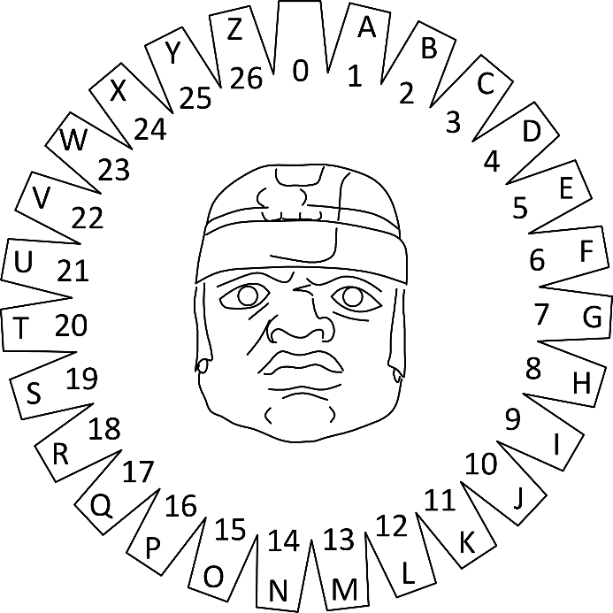right), by counting from the beginning (**zero**) and going **clockwise**. You may count **more than one full revolution** around the wheel (e.g. 6 is the same as 33 and so on). Repeat this process for all symbols of the message.

If the decoding template matrix is **smaller** than the message, **shift the template** **horizontally** by as many cells as it is wide, so it covers the next section of the message (see example). Once you reach the last column of the message matrix, if there are more rows left, **shift** the template back to the **first column**, but **offset it vertically** by as many cells as it is high. See the example’s explanation for more information.

**Input**

You will receive an **array of strings**. The first element represents a number **n**, which is the length of the **template matrix** for decoding. The next **n** elements represent rows in the decoding template matrix, with columns **separated by space**. The rest of the elements are all rows of the **encoded message matrix**, with columns in each row **separated by space**.

**Output**

Print the decoded message in **uppercase** on a single line on the **console**. The final message is joined from all resulting cells, starting from **top left**, going right, **row by row**. Trailing spaces are **ignored**.

### Examples

|  |  |
| --- | --- |
| **Input** | **Output** |
| [ '2',  '59 36',  '82 52',  '4 18 25 19 8',  '4 2 8 2 18',  '23 14 22 0 22',  '2 17 13 19 20',  '0 9 0 22 22' ] | I CAME I SAW I CONQUERED |

#### Explanation

The line highlighted in red in the input is the number of lines of the decoding template matrix. The lines highlighted in blue are the decoding template itself. The remaining lines are the encoded message matrix. When we overlay the template over the message, 59 and 36 from the first line are on top of 4 and 18, 82 and 52 are on top of 4 and 2.

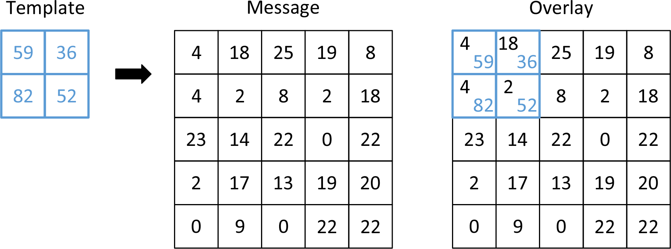

|  |  |  |
| --- | --- | --- |
| We add each pair to get 63 and 54 on the first line and 86 and 54 on the second. Looking up these numbers on the wheel of letters yields the following:   * For 63 we count two full revolutions and then we count 9 more, which corresponds to the letter ‘I’ * For 54 we count exactly two full revolutions, ending at 0, which is empty space * For 86 we count 3 full revolutions and 5 more, ending at ‘E’ * For 54 we get empty space again | |  |
| We’ve ran out of slots on the template, so we shift it 2 indexes to the right (the width of the template is 2), to decode the next segment of the message. This time we overlay it on top of 25, 19, 8 and 2 and after adding the numbers, we get 84, 55, 90 and 54. They correspond to ‘C’, ‘A’, ‘I’ and empty space, respectively. | |  |
| We keep repeating this for the entire message. Once we reach the end of the row, we shift the template down by its height (2 cells) and back to the beginning of the message. Any slots of the template that overhang at the end of the row are ignored. |  | | |
| The process is repeated for all remaining cells of the message. Note any parts of the template matrix that overhang bellow are ignored. | | | |
|  | | | |
|  | | | |

|  |  |
| --- | --- |
| **Input** | **Output** |
| [ '2',  '31 32',  '74 37',  '19 0 23 25',  '22 3 12 17',  '5 9 23 11',  '12 18 10 22' ] | WE COME IN PEACE |